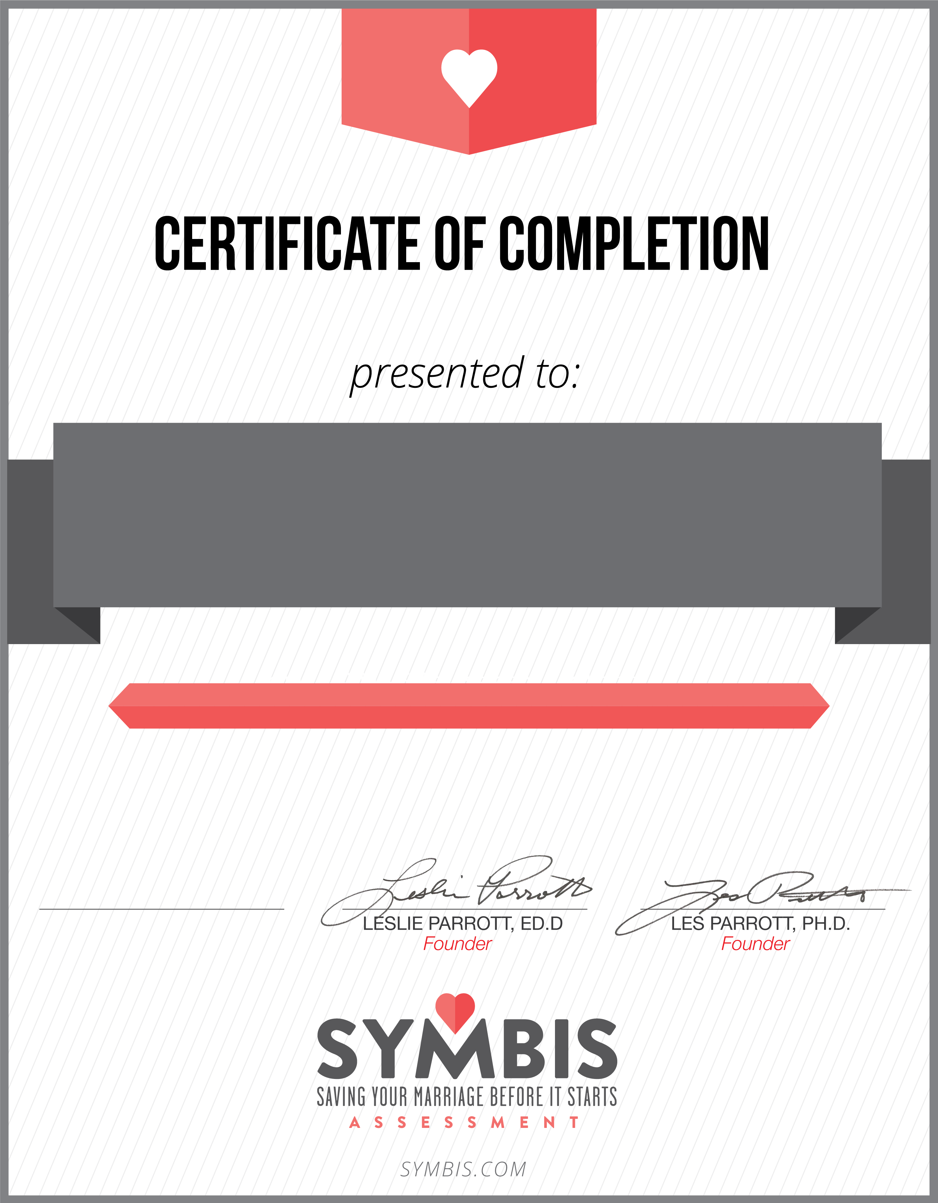
On September 8th, 2015, the above named couple completed our church’s pre-marriage program including the completion of the SYMBIS Assessment. It is our prayer for them to enjoy a lifetime of love together.
New Creation Fellowship Church
Pastor kingsley okemwa

10-Hour Pre-Marriage Course
Dickson Ngala & Deborah

