Started on | Sunday, 29 August 2021, 7:07 PM
State | Finished
Completed on | Sunday, 29 August 2021, 7:35 PM
Time taken | 28 mins 16 secs
Marks | 11.00/11.00
Grade | 10.00 out of 10.00 (100%)

Question 1
Correct
Mark 1.00 out of 1.00
Flag question

Question text
What is placed over a diphthong to indicate the letters ought to be pronounced separately? (The two dots in the word Ἠσαΐας, for example).
Select one:
a. Crasis
b. Rough Breathing Mark
c. Diaeresis
Correct.
d. Elision

Feedback
Your answer is correct.
The correct answer is: Diaeresis

Question 2
Correct
Mark 1.00 out of 1.00
Flag question

Question text
What is a diphthong?
Select one:
a. A combination of three or more letters
b. A combination of a vowel and a consonant
c. A combination of two vowels
Correct.
d. A combination of two consonants

Feedback
Your answer is correct.
The correct answer is: A combination of two vowels

Question 3
Correct
Mark 1.00 out of 1.00
Flag question

Question text
How many letters are there in the Greek alphabet?
Answer:

Feedback
Correct.
The correct answer is: 24

Question 4
Correct
Mark 1.00 out of 1.00
Flag question

Question text
True or False: If a word begins with a consonant, it must have a breathing mark.
Select one:
True
False

Feedback
Correct.
The correct answer is 'False'.

Question 5
Correct
Mark 1.00 out of 1.00
Flag question

Question text
True or False: Long and short vowels refer to the relative length of time it requires to pronounce the vowel.
Select one:
True
False

Feedback
Correct.
The correct answer is 'True'.

Question 6
Correct
Mark 1.00 out of 1.00
Flag question

Question text
What is the small iota written under certain vowels called?
Select one:
a. A furtive iota
b. An iota diphthong
c. An iota subscript
Correct.
d. Diaeresis

Feedback
Your answer is correct.
The correct answer is: An iota subscript

Question 7
Correct
Mark 1.00 out of 1.00
Flag question

Question text
Match the following Greek lowercase letters with their equivalent sounds:
ω | Answer 1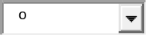
ι | Answer 2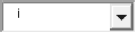
κ | Answer 3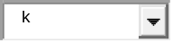
ξ | Answer 4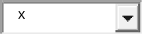
ν | Answer 5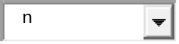
υ | Answer 6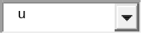
γ | Answer 7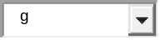
χ | Answer 8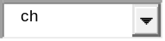
π | Answer 9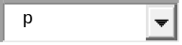
ε | Answer 10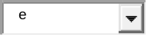
ψ | Answer 11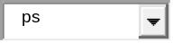
ρ | Answer 12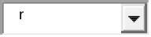
λ | Answer 13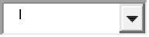
β | Answer 14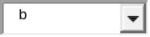
τ | Answer 15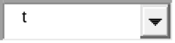
ο | Answer 16
η | Answer 17
σ, ς | Answer 18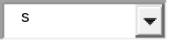
ζ | Answer 19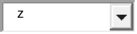
α | Answer 20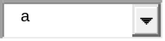
δ | Answer 21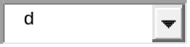
θ | Answer 22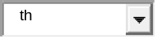
μ | Answer 23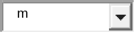
Φ | Answer 24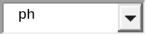

Feedback
Your answer is correct.
The correct answer is: ω → ō, ι → i, κ → k, ξ → x, ν → n, υ → u, γ → g, χ → ch, π → p, ε → e, ψ → ps, ρ → r, λ → l, β → b, τ → t, ο → o, η → ē, σ, ς → s, ζ → z, α → a, δ → d, θ → th, μ → m, Φ → ph

Question 8
Correct
Mark 1.00 out of 1.00
Flag question

Question text
Which of the following is not vowel?
Select one:
a. τ
Correct.
b. α
c. η
d. ο

Feedback
Your answer is correct.
The correct answer is: τ

Question 9
Correct
Mark 1.00 out of 1.00
Flag question

Question text
How should you pronounce two gammas (γγ)?
Select one:
a. Like a single “g”
b. Like the ng in “angel”
Correct.
c. Like the letters “gly”
d. Like the gg in “eggs”

Feedback
Your answer is correct.
The correct answer is: Like the ng in “angel”

Question 10
Correct
Mark 1.00 out of 1.00
Flag question

Question text
Which of the following letters is classified as a “nasal”?
Select one:
a. Sigma - σ
b. Eta - η
c. Omicron – ο
d. Nu - ν
Correct.

Feedback
Your answer is correct.
The correct answer is: Nu - ν

Question 11
Correct
Mark 1.00 out of 1.00
Flag question

Question text
Which Greek letter has two forms, one written only at the end of words?
Select one:
a. Beta
b. Sigma
Correct.
c. Xi
d. Theta

Feedback
Your answer is correct.
The correct answer is: Sigma

