Solving My People Puzzle Assignment Instructions
Overview

When working with others, it is important to consider how personality patterns influence interpersonal effectiveness. To effectively work with and provide ministry to others, we must promote self-awareness in the practice of relational alignment and personality management. In the process of becoming effective, efficient, and relationally-wise ministers, we must learn to recognize and meaningfully manage our own style in different relational contexts.

The Solving My People Puzzle Assignment provides a means to describe, develop, and manage your relational style’s influence. Through the Solving My People Puzzle Assignment, you will develop a Guiding Purpose Statement (GPS), describe your DISC personality style, and analyze how you would practice relational alignment in different relational contexts.

The Solving My People Puzzle Assignment includes five sections that are organized through five key questions. In Question 1, you will discuss your Guiding Purpose Statement (GPS). Question 2 covers the results of your Uniquely You DISC assessment. Question 3 addresses relational alignment with each of the primary DISC types (i.e., D, I, S, C). In Question 4, you will consider how to build rapport and practice DISC-specific relational alignment with your predetermined care-seeker. Finally, Question 5 should contain insights from your Mentor’s 360° Interview Worksheet Template and information on how you would practice relational alignment with your mentor. For information on each section, please see the Solving My People Puzzle Questions below.

Instructions

- The body of your paper should be double spaced and at least 5 pages.
- Your research and writing style should follow current APA or Turabian standards.
- SMPP paper should have a correct .docx file name – e.g., PACO500_SMPP+YourInitials.
- Section headers are required.
- Your paper should include a title page, five sections answering the SMPP paper Questions (see details on the Questions below), and a conclusion. The conclusion should present a “So What? of it All!” This is a recap which concludes with a clear description of the main takeaways from the assignment.
- Include an appendix with screenshots of DISC Graph 1 & 2 (this is me/this is expected of me).
- Please note that there are 7 required sources that need to be cited in your paper. At least these 7 sources must be cited in current APA or Turabian format
  - Professional/Leadership Uniquely You DISC Profile
  - How to Solve the People Puzzle (2008)
  - DISC Personality Testing (Copy and paste the link into your browser: https://discpersonalitytesting.com/.)
  - Masterpiece (2017)
  - Why Don’t We Listen Better? (2015)
  - Mentor’s 360 Interview Worksheet Template
  - Case Study – Crossroads: A Story of Forgiveness
- Note: Your assignment will be checked for originality via the SafeAssign plagiarism tool.

Solving My People Puzzle Questions

- What Guiding Purpose Statement will govern your relationship with God in the midst of every relational context?

The first question (Question 1) requires you to articulate a concise Guiding Purpose Statement (GPS) in the required format (see below). You will also provide a brief paragraph of context to describe your choice of GPS. For detailed instructions on formatting the GPS, see below.
- A clearly defined GPS will govern the process of being and becoming like Christ in a specific way in a specific relational context.
- With this in mind, create your GPS by providing one-word descriptors in the blanks below. The GPS should take this specific format: “Seeking to be a/an
- [ ] of Christ, I am committed to become a/an [_______________] [_______________].”
- When filling in the blanks, use one word descriptors. For example, one of the following words might describe who you want to be in your relationship with Jesus: example, imitator, follower, representative, reflection, beacon, fragrance, etc. If any of these do not work for you, find one that does!
- As a purpose statement, the GPS should influence your relational behaviors. For example, your GPS could look something like this: “Seeking to be an imitator of Christ, I am committed to become a considerate supervisor.” Or your GPS might be crafted as: “Seeking to be an example of Christ, I am committed to become an attentive husband.”
- After you provide your GPS in the format listed above (i.e., Seeking to be a ______ of Christ, I am committed to become a ______ _______), provide a paragraph to describe why you chose this GPS and how you want God to use it in your interpersonal context(s)!

- Can you describe “Who I am”?

In providing an answer for Question 2, review the results from your Professional/Leadership DISC Profile. Use the feedback from the Professional/Leadership DISC assessment and the following bullets to describe your current relational style. Respond to this question in a source-supported, thoughtful fashion. Describe your DISC through the lens of “this is me” and “this is expected of me” as shown below. Use source citations and provide insight into your DISC style.

  - This is Me! (Graph 2) –

  - This is Expected of Me (Graph 1) –

- In light of your DISC style, can you point out how you would shift your style (i.e., build common ground; 1 Cor. 9) in order to align with each of the four primary styles?

In Question 3, you should discuss how you would practice relational alignment (i.e., building rapport and creating a meaningful connection) with each of the primary DISC types (D, I, S, or C). Thoughtfully integrate insights (i.e., source citations) from the required sources as you discuss how to shift your style with each of the primary DISC patterns. For example, if you are primarily a D/C, how you would practice relational alignment with a D type? Explain how you would shift your “D/C-ness” to align with someone who has a predominate D style. Do that for each of the four primary DISC styles.

Respond to the following bullets to point out how you would shift your style to align with a D, I, S, and C.
- [Your Style] aligned with a D
- [Your Style] aligned with an I
- [Your Style] aligned with a S
- [Your Style] aligned with a C
Alignment should:
- Provide meaningful insights into alignment with each of the primary DISC types. Your paper should include the headings listed above.
- Include pertinent citations from the paper’s 7 required sources!
- Use language that describes your behavioral patterns (e.g., strengths, shortcomings, blind spots, etc.) and provide information on how to manage them in each DISC context.
- Point out how will you communicate and connect with a predetermined care-seeker from the case study?
In Question 4, you will describe the process of building rapport and practicing DISC-specific relational alignment with your predetermined care-seeker. Your answer will inform a practice people-helping relationship. See steps below.

- Choose a care-seeker from the case study (i.e., Bruce, Josh, Brody, Melissa, or Justin).
- After reviewing the case study, make an informed guess and briefly describe the care-seeker’s DISC relational style (see Carbonell for explanation of the DISC types).
- Use DISC-specific language to describe at least 1 interpersonal communication technique that will overcome one of your communication traps and increase your ability to listen with empathy, genuineness, and graciousness. Provide at least 2 helpful insights from course sources and 1 related Scripture.
- Point out how you will shift your DISC style to align with your care-seeker’s DISC style.

- Can you point out how will you communicate and connect with your mentor?

In Question 5, you will discuss insights from your mentor and describe how you would practice relational alignment in a practice mentoring relationship. Your answer to Question 5 should include DISC-specific information and insights from the mentor’s 360° Interview Worksheet. See steps below.

- Solicit someone to be your practice mentor and ask him/her to complete the following assessments.
  - Mentor’s 360° Interview Worksheet Template (Review the Solving My People Puzzle Instructions and Grading Rubric)
  - A free abridged DISC personality test. Ask mentor to copy/paste the link provided into the web browser: https://discpersonalitytesting.com/discassess/work-free/free-start.php. You need your mentor’s DISC results for your discussion of relational alignment in Question 5.
- Use source support, insights from your Mentor’s 360° Interview Worksheet Template, and mentor’s DISC style to point out how you will shift your DISC style to align with mentor’s style. Provide source citations and insights into how you would build rapport and shift your style to align with your mentor. This section should include insights from the Mentor’s 360° Interview Worksheet Template and from the DISC assessment.

Preliminary Tasks for Completing the Solving My People Puzzle Assignment
You can utilize this section as a checklist. Information on how to access the Uniquely You DISC assessment and complete other steps are below.
- Complete your DISC assessment. Self-administer the online Professional/Leadership DISC Profile (Expanded Version-Standard) from Uniquely You Resources, Inc.
- If you purchased the online access code from BNC Virtual, follow instructions below.
  - BNC Virtual purchasers, go to the Uniquely You website link: https://uniquelyyou.org/.
  - Click on Register in the top right hand corner of your browser and supply a user name, password, and LU email. Remember that data!
  - Once a user name and password have been created, click on the top of the page “Activate Code”
  - Enter your 8 or 12 digit code and confirm it.
  - Go to “My Account” and click the green “Begin Questionnaire” button.
  - Complete the profile.
  - After completion, see *How to Download PDF below.
- If you are uncertain where to purchase the Uniquely You Professional Leadership DISC, you can access the purchasing link by copying the web link into the web browser: https://uniquelyyou.org/content/professional-online-profile-approx-70-printed-pgs-expanded-version.
- Make sure to give careful attention to assessment instructions. Typically, the directions ask that you answer only two descriptions for each set of four statements: what you are most often like under pressure, and what you are least often like under pressure.
- See example questions below.
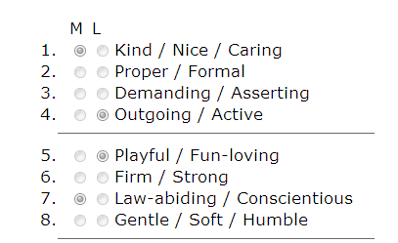
- If you purchased the access code directly from Uniquely You, the code automatically shows up in your “My Account” page (no need to activate it). Simply go to the My Account page and click “Begin Questionnaire.” After completion, see *How to Download PDF below.
  - *How to Download a PDF of your Report
- Put a check in the box next to name column of assessment completed
- Click the “Download Report” (2nd blue button under Profile List)
  - If you have any questions or issues, please contact Uniquely You @ 800-501-0490.
- Place Graphs 1 and 2 (“This is Expected of Me” and “This is Me”) in the Appendix via a screenshot, Snip-it, or the free TechSmith Capture/Jing Tool: https://www.techsmith.com/jing-tool.html. See example snapshots of Dot Graphs below:
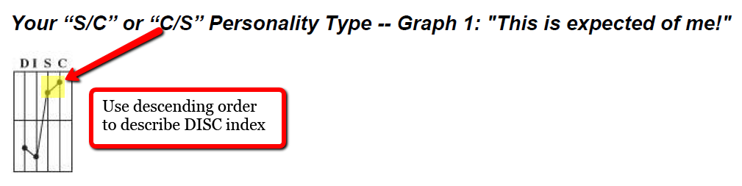
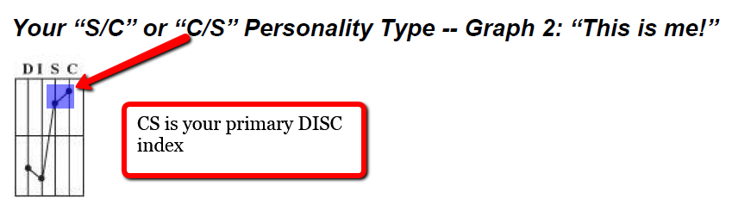
- Identify a “practice mentor” and ask him/her to complete 3 tasks (relates to Question # 5):
  - Mentor’s 360° Interview Worksheet Template
  - Free abridged DISC assessment
  - Return results ASAP
- Write your Solving My People Puzzle paper by answering five key questions (see instructions in sections above).

