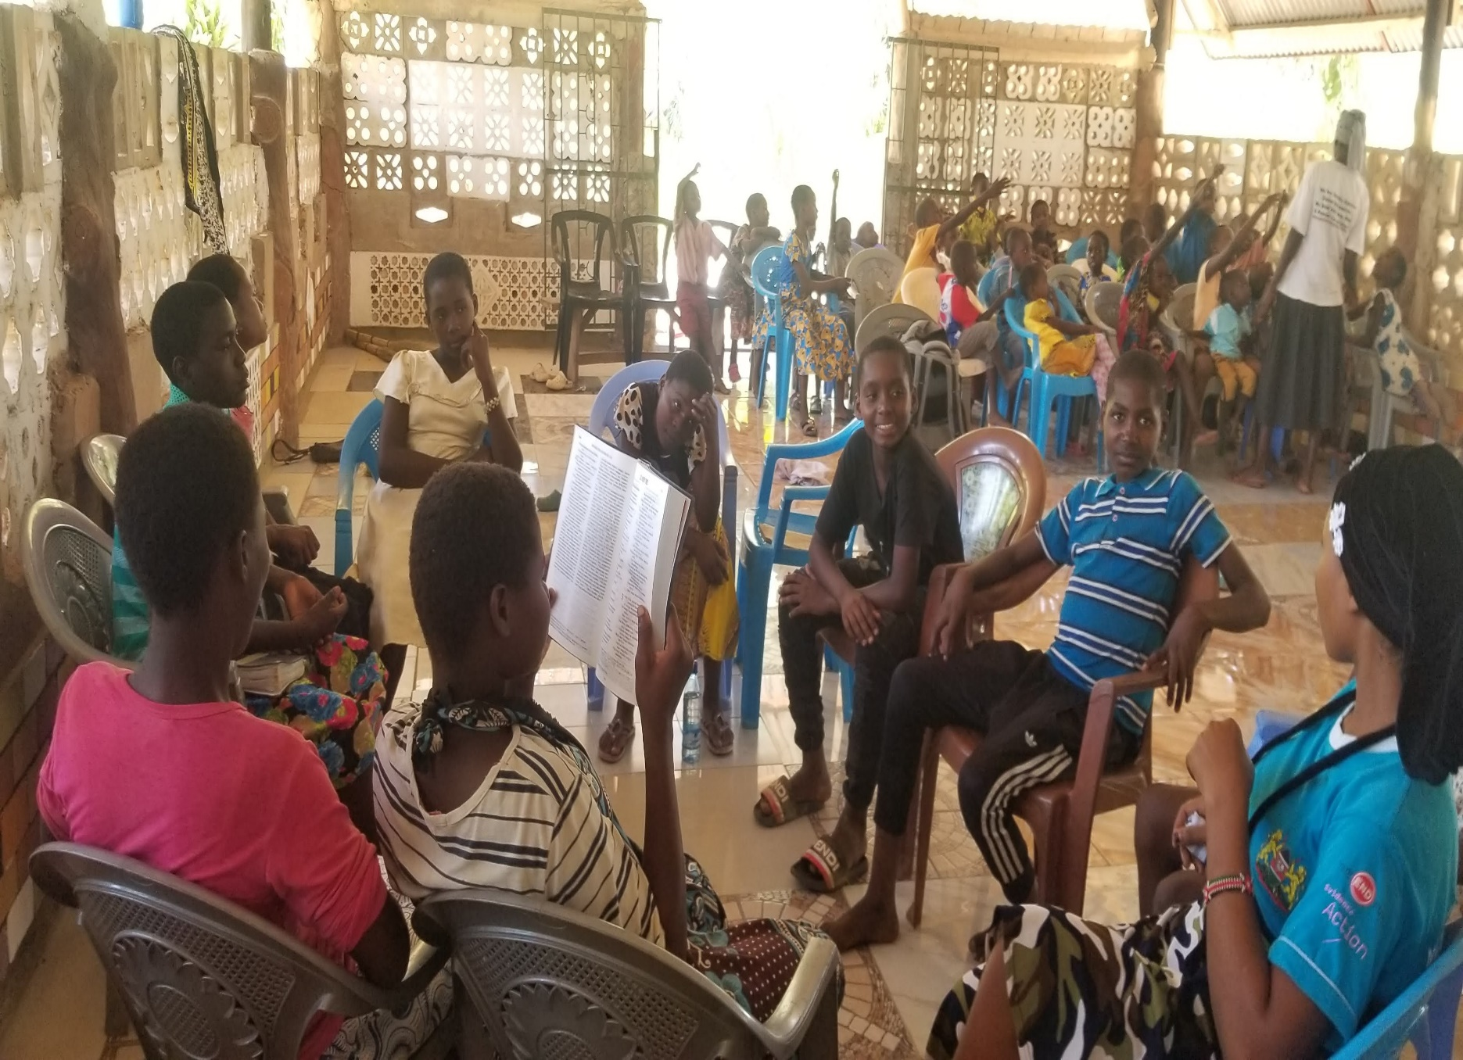

KWALE MISSION REPORT 2021

July 16

NAIROBI BAPTIST CHURCH
Authored by: KINGSLEY OKEMWA

Greetings in the name of our Lord Jesus Christ! Below, you will read a report sharing a snapshot of the ways God has been using missions to reach out into the community. God has blessed us with fruitful ministry in this second quarter of the year and I hope to share a piece of that with you in this report as I talk about PPI, youth ministry and visitations.

PPI
This quarter I have been focusing on making sure that Dima Primary has trained and qualified PPI teachers for each class. I have been working with the pastors not only to recruit teachers they feel are gifted but also to go into the schools and teach themselves. At this point we have six teachers that go each week to Dima Primary School for PPI and twenty other teachers that are being trained to be sent out to the four other Mazumalume schools. By the end of the year, we hope that all five of these schools will have a flourishing PPI program. The students are really having a great time and they are learning weekly about Jesus and the Bible.
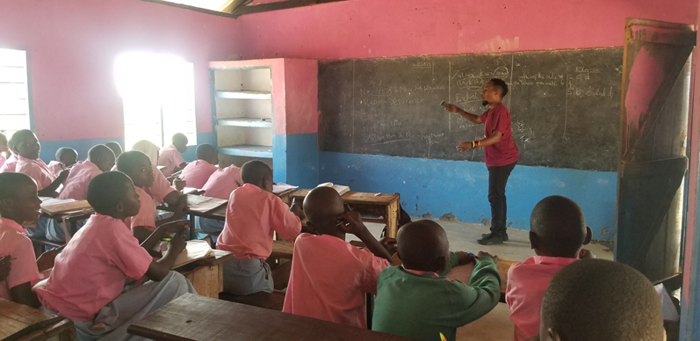
(PPI at Dima Primary school)

Youth Ministry
The youth ministry is split into three parts, Bible study/dance, Mazumalume youth, Bapo Scholars alumni. Every Saturday afternoon young people gather at pastor Omari’s church for a Bible study and a time of learning dances together. This activity has been a favorite and continues to grow every week. Currently there are around 30-40 young people that come every week for this activity.
In May we elected leaders for the Mazumalume youth ministry. These leaders have stepped up to the plate and have already began planning activities and mobilizing the youth in the area. In June they held a youth conference at Mbegani Church and invited Missionary Preston to come and speak about, “Our Identity In Christ” This event was a huge success as 319 youths attended. Currently they are planning a concert for the youth that will be at the end of this month.
Currently our Bapo scholars alumni group has nine individuals. We have been mentoring these young people as they are finishing school and looking to begin university in the next year. We meet each time when school is out to play games, hang out and take time to focus on career mentorship. In May we helped three of them to apply for college and choose the career they plan to pursue.
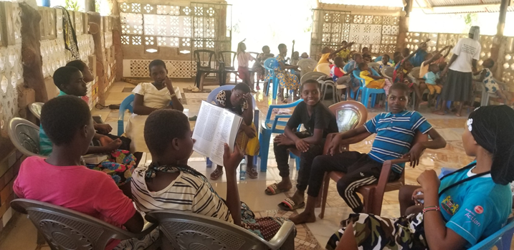
(Weekly Bible study at Redeemed Church Mbegani)
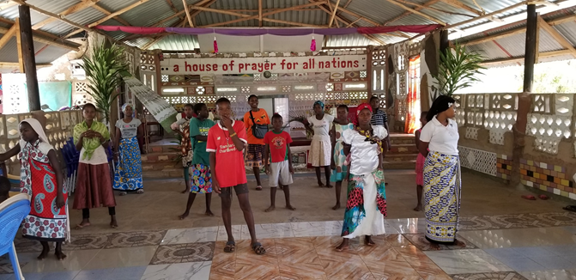
(Dancing with the youth)
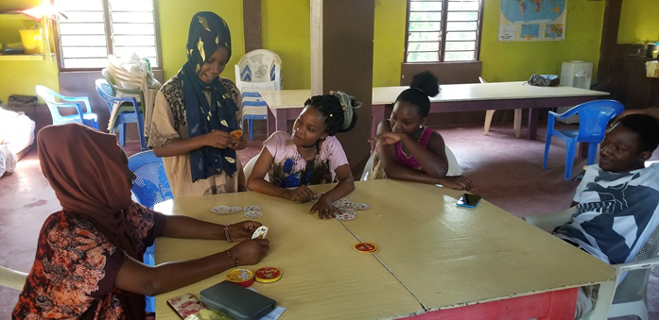
(Bapo Scholars hang out)

Visitations in the Community
Every week I go out into the community and visit different individuals and families. I go out and pray with the sick, disciple new believers, encourage families and show acts of kindness by giving a small shopping when I visit families in need.

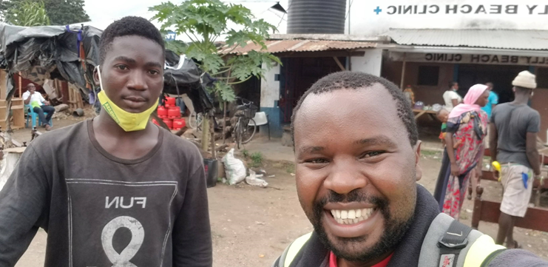
(Visiting Bapo Scolar, Nyerere in his home)
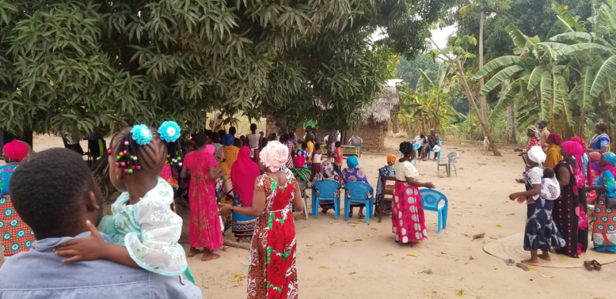
(Celebrating the healing of a Redeemed church members daughter)

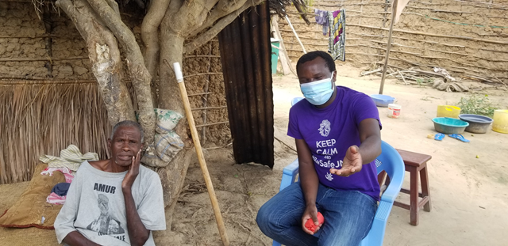
(Praying with this mzee who was very ill and is doing much better now)

